

**THE STATE UNIVERSITY OF ZANZIBAR**

**SCHOOL OF NATURAL AND SOCIAL SCIENCES**

**DEPARTMENT OF COMPUTER SCIENCE AND INFORMATION TECHNOLOGY**

**FINAL YEAR PROJECT REPORT**

**PROJECT TITLE : AIRPORT RESTROOM’S MANAGEMENT SYSTEM**

**STUDENT NAME : YASSIR MUSSA JUMA**

**REG NO : BITAM/9/21/046/TZ**

**SUPERVISOR NAME : DR. ALI IDAROUS ADNAN**

# DECLARATION

I’m YASSIR MUSSA JUMA, hereby declaring that, this is my own original work,

# ABTSRACT

This project is an IoT based together with web application which aims at improving quality of the airport toilets, the project includes detecting toilet users and sending message based on the desired count in which toilet maybe found to be in bad condition, also the it involves detecting toilet condition and send message to cleaners when toilet is in poor condition, also it enable toilet users to rate the toilet condition as good or poor.

Contents

DECLARATION 2

ABTSRACT 3

Table of Figures 5

CHAPTER 1: Introduction 6

CHAPTER 2: Methodology 7

CHAPTER 3: Requirements Analysis and Modelling 8

4. CHAPTER 4: System Design 13

# Table of Figures

Figure 1 Use case diagram 9

Figure 2 Sequence Diagram 11

Figure 3 entity relationship diagram 12

# CHAPTER 1: Introduction

* 1. Description of the project and background

Airport toilet are normally cleaned as other toilets in the public sectors where cleaners go to clean through the toilets.

* 1. Problem statement

Airport is a public sector used by many people including foreigners, these toilets miss the punctual cleaning since there is no exact materials that will recommend to clean the toilet. Also there is no feedback mechanism for the toilet users to make sure services is in the better quality.

* 1. Problem solution and the scope

The solution is to develop an IoT with web based system that will detect the toilet condition so that message will be sent when the toilet condition is poor, also the system will count the number of toilet users for the required time and send message for the cleaners to clean the toilets, also system will provide feedback mechanism for the toilet users to rate the services.

This is generally important for improving toilets quality in the airport so that visitors will be satisfied with the service.

* 1. Objectives

The main objective of this project is enhancing the quality of toilet service at the airport.

1. To detect toilet condition using gas sensor.
2. To count number of toilet user.
3. To collect user’s feedback
   1. Project background and motivation

The motivation toward this project is the potential improvements of toilet service in the airport

* 1. Feasibility study.

1. Economic

The project requires one esp 32 board, one ultrasonic sensor, a gas sensor, two push buttons, a GSM module and some jumper wires, which in generally cost about TZS 60000.

1. Legal

The project is not against any legal considerations, it also does not violate privacy.

1. Technical feasibility

The project is developed through IoT which uses C++ and Django for web development for management.

# CHAPTER 2: Methodology

2.1 Requirement gathering methods.

I used interview method in requirement collection, among the questions used are:

1. How the operation occurs?
2. How many times toilets are cleaned a day?
3. Is there anyone who supervise the operation?

2.2 Software development life cycle.

I used agile software development life cycle because of its scalability which allows customer requirements anytime.

# CHAPTER 3: Requirements Analysis and Modelling

* 1. Requirement determination
     1. Existing system.

3.1.1.1 Existing system description

Currently cleaners clean the toilet early morning as their first time, then they observe the toilet condition physically for recleaning the toilet. This imposes human errors as they can’t observe the toilet every time, thus an automated practice is needed.

* + - 1. Business Rules

Rules governing

* + 1. Proposed system.

The proposed system is an IoT and web-based system which will detect toilet condition and send message to cleaners automatically, also it will count number of toilet users and send message to the cleaners based on specified count, also the system will provide feedback mechanism for managerial assessment of the cleanrers.

* + 1. Functional Requirements.

1. The system should detect toilet condition.
2. The system should count number of toilet users.
3. The system should send message to cleaners.
4. The system should provide feedback mechanism for toilet users to rate the services.
   * 1. Non-functional requirements.
5. The should be accurate enough for it to be reliable.
6. The system should be secured to allow only authenticated and authorized persons to view the record.
   1. Requirements Structuring.
      1. Process Modelling

3.2.1.1 Use case diagram

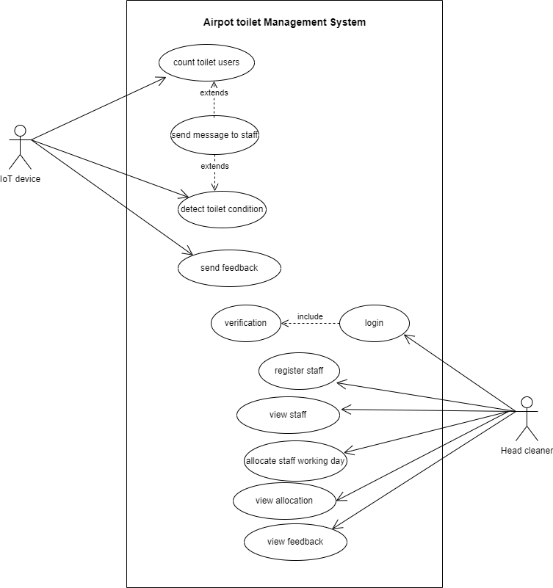

Figure 1 Use case diagram

* + - 1. Use Case documentation

|  |  |
| --- | --- |
| Use Case | Description |
| Detect toilet condition | This is achieved by using gas sensor |
| Count toilet users | This is achieved by using ultrasonic sensor |
| Send messages | This is done if toilet condition is poor or if count is equal to the desired count |
| Send feedback | The push buttons will achieve this when users press bush button |
| Register staff | This is web-based part done by management |
| Allocate staff | Here staff are allocated to their working days |
| View feedback | Here management see rating of their staff by users |

* + - 1. Sequence Diagram

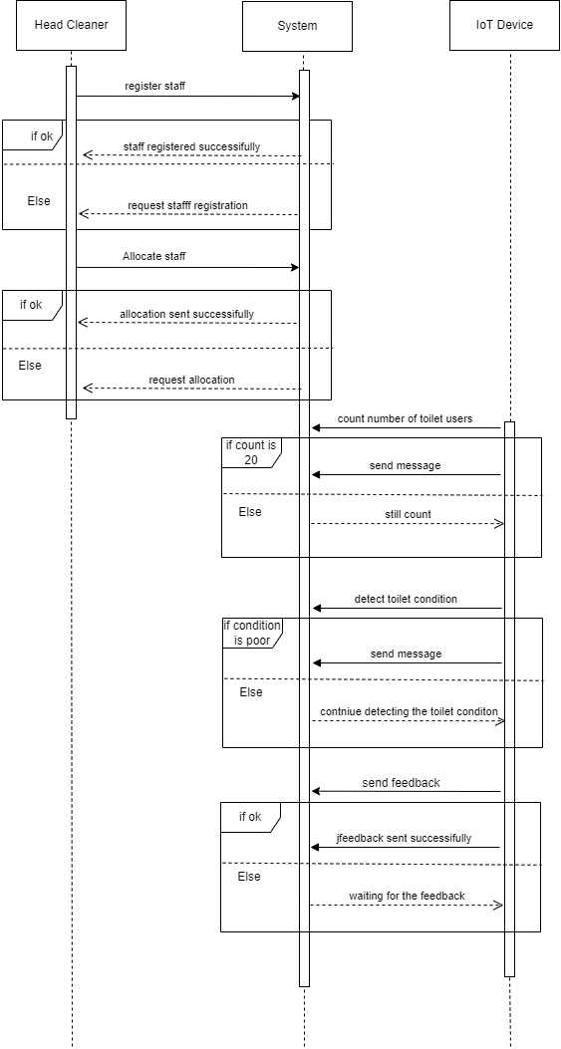

Figure 2 Sequence Diagram

* + 1. Data Modelling

3.2.2.1 Entity relationship diagram

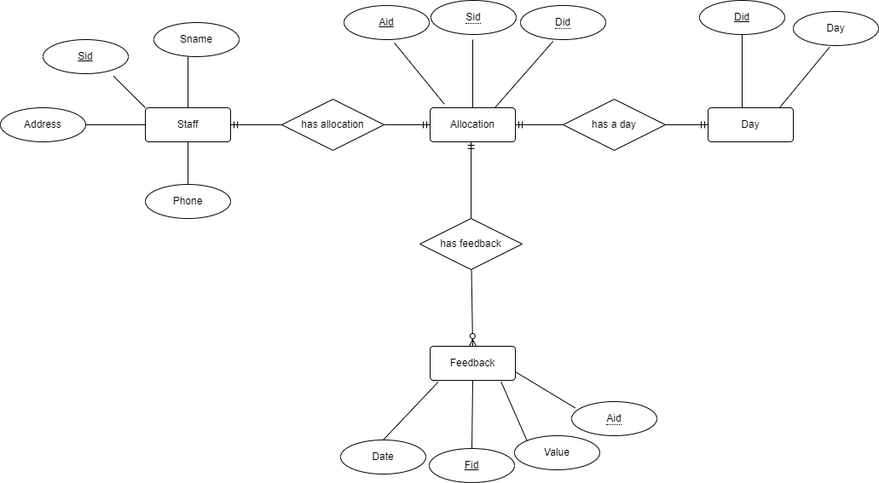

Figure 3 entity relationship diagram

# 4. CHAPTER 4: System Design

4.1. Architectural design

4.1.1. High-Level Architecture Diagram

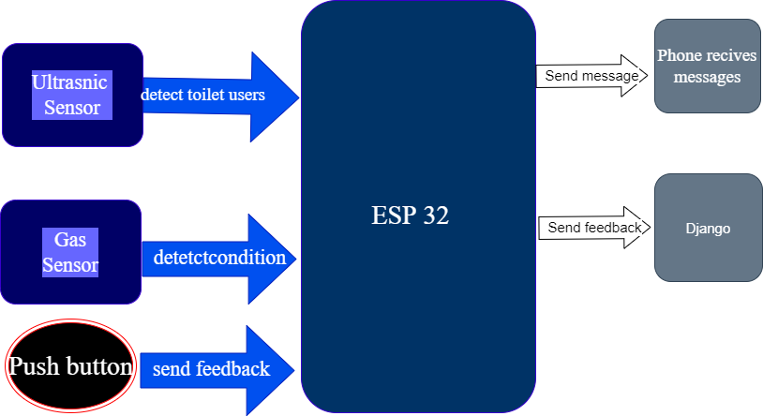

Components used in the system

|  |  |  |
| --- | --- | --- |
| Component | Amount | Cost per item |
| Esp 32 | 1 | 20,000/- |
| Gsm module | 1 | 15,000/- |
| Ultrasonic sensor | 1 | 5000/- |
| Jumper wire | 3 | 2000/- |
| Gas sensor | 1 | 10,000 |
| Push button | 2 | 3500/- |
| Lithium battery | 1 | 10,000/- |